East-West Network Traffic

🔁 What Is East-West Network Traffic?
# Source: AI Source: Provided by: [Data Path: Persons Table -> ID Column: 1, Name_En Column: Motasem Essam] -> From: [ChatGPT] on [12/18/2025]
East-West traffic refers to data that moves laterally (side-to-side) within a data center or internal network — typically between servers, virtual machines (VMs), containers, or applications.

🧠 Simple Definition:
# Source: AI Source: Provided by: [Data Path: Persons Table -> ID Column: 1, Name_En Column: Motasem Essam] -> From: [ChatGPT] on [12/18/2025]
East-West traffic is internal network communication, such as between two servers in the same data center or between microservices within a cloud environment.

🧭 Why “East-West”?
# Source: AI Source: Provided by: [Data Path: Persons Table -> ID Column: 1, Name_En Column: Motasem Essam] -> From: [ChatGPT] on [12/18/2025]
In networking, directions are metaphorical:
- North-South traffic = Between internal systems and the outside world (e.g., users, internet)
- East-West traffic = Between internal systems within the same network or environment

🧰 Common Examples of East-West Traffic
# Source: AI Source: Provided by: [Data Path: Persons Table -> ID Column: 1, Name_En Column: Motasem Essam] -> From: [ChatGPT] on [12/18/2025]
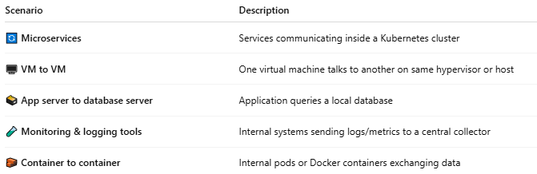

Scenario | Description
🔄 Microservices | Services communicating inside a Kubernetes cluster
🖥️ VM to VM | One virtual machine talks to another on same hypervisor or host
🗃️ App server to database server | Application queries a local database
🧪 Monitoring & logging tools | Internal systems sending logs/metrics to a central collector
🧱 Container to container | Internal pods or Docker containers exchanging data

📡 Characteristics of East-West Traffic
# Source: AI Source: Provided by: [Data Path: Persons Table -> ID Column: 1, Name_En Column: Motasem Essam] -> From: [ChatGPT] on [12/18/2025]
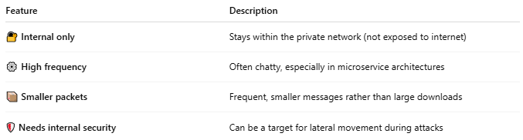

Feature | Description
🔐 Internal only | Stays within the private network (not exposed to internet)
⚙️ High frequency | Often chatty, especially in microservice architectures
📦 Smaller packets | Frequent, smaller messages rather than large downloads
🛡 Needs internal security | Can be a target for lateral movement during attacks

🔐 Security Focus for East-West Traffic
# Source: AI Source: Provided by: [Data Path: Persons Table -> ID Column: 1, Name_En Column: Motasem Essam] -> From: [ChatGPT] on [12/18/2025]
- 🔒 Microsegmentation – Isolate workloads using software-defined policies
- 🔍 East-West firewalls – Monitor internal traffic, not just inbound/outbound
- 🧠 Zero Trust – Authenticate all communications even inside the network

🆚 East-West vs North-South Traffic
# Source: AI Source: Provided by: [Data Path: Persons Table -> ID Column: 1, Name_En Column: Motasem Essam] -> From: [ChatGPT] on [12/18/2025]
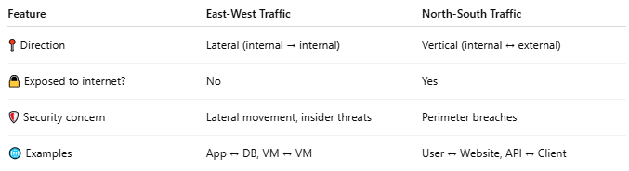

Feature | East-West Traffic | North-South Traffic
📍 Direction | Lateral (internal → internal) | Vertical (internal ↔ external)
🔒 Exposed to internet? | No | Yes
🛡 Security concern | Lateral movement, insider threats | Perimeter breaches
🌐 Examples | App ↔ DB, VM ↔ VM | User ↔ Website, API ↔ Client

📌 Summary
# Source: AI Source: Provided by: [Data Path: Persons Table -> ID Column: 1, Name_En Column: Motasem Essam] -> From: [ChatGPT] on [12/18/2025]
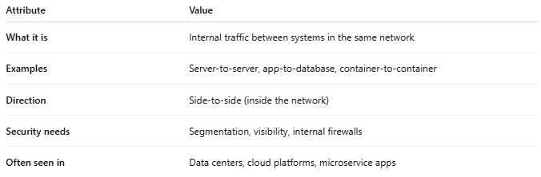

Attribute | Value
What it is | Internal traffic between systems in the same network
Examples | Server-to-server, app-to-database, container-to-container
Direction | Side-to-side (inside the network)
Security needs | Segmentation, visibility, internal firewalls
Often seen in | Data centers, cloud platforms, microservice apps

